DJ Simulator – Project Interim Demo

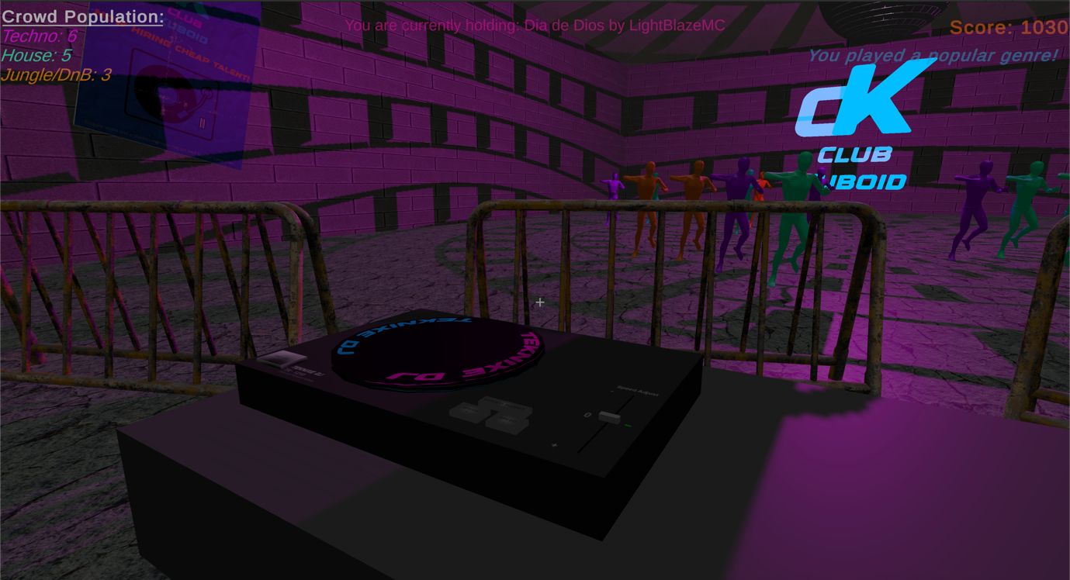

***What has been achieved so far:***

* A scoring system has been implemented.
* NPC balancing system has been implemented, making sure that the game awards points appropriately.
* NPCs now dance when they like the music, or idle when they don’t.
* Scripts have been fixed, making sure that the game logic can comprehend the player’s actions correctly.
* The player can load tracks onto the decks and select music.
* The player can traverse across the dance floor map.
* The environment reacts to audio via a comprehensive audio binary data analysis system.